Contact Us Page

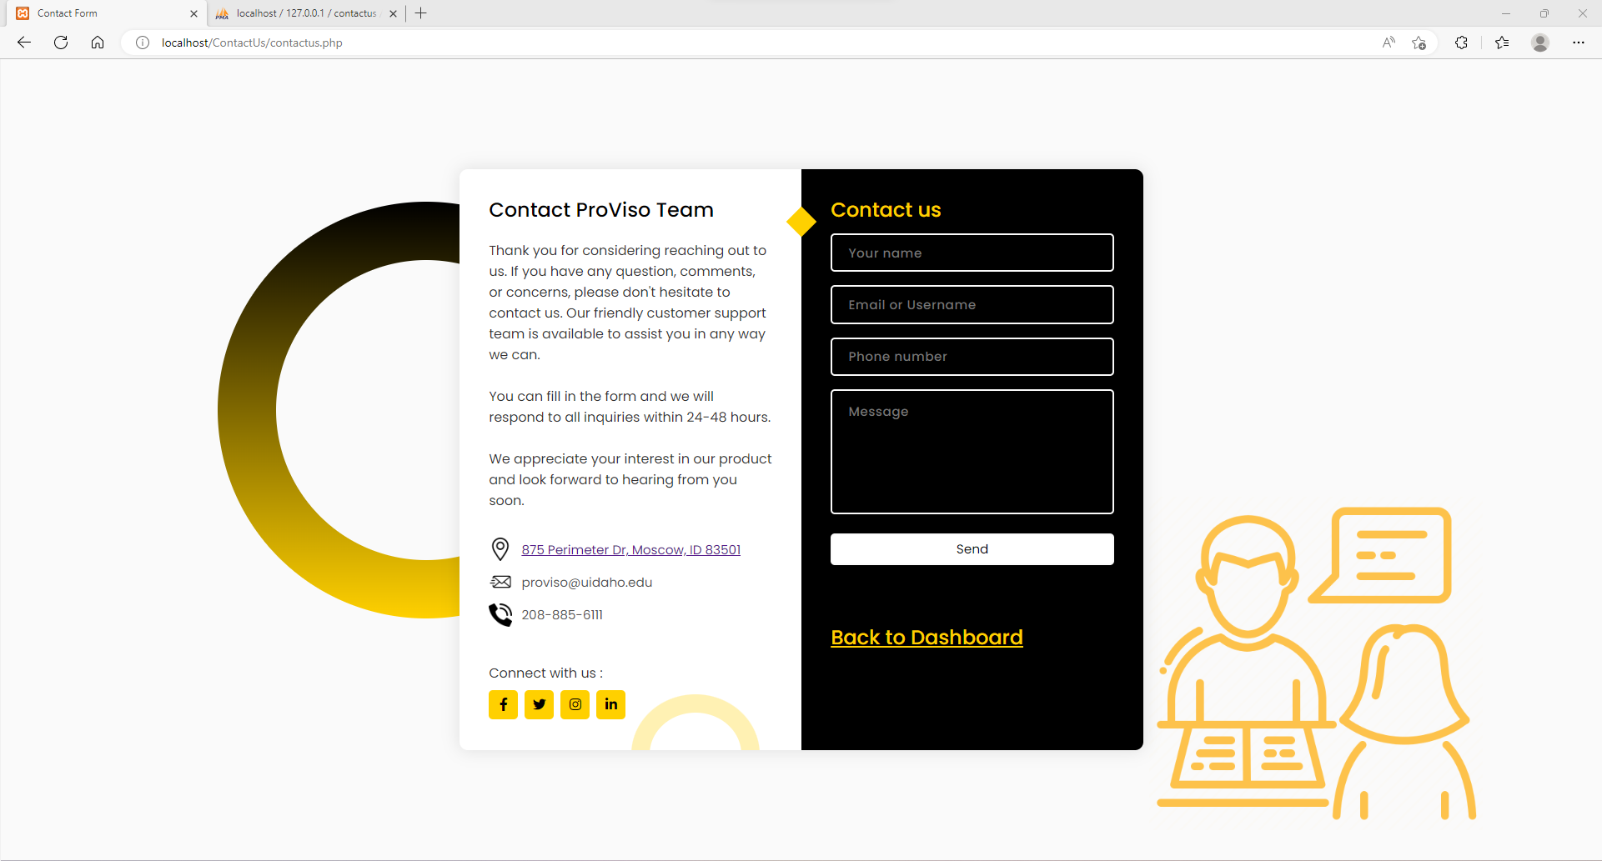

Fill in the Contact Us form

Send the form

The form will be in SQL table with all the information (their name, email, phone, message, and when the person send the form)

